**University of Petroleum and Energy Studies**

School of Computer Science

Department of Cybernetics



**Graphics & Animation Tools**

**LAB FILE**

**(Session: 2020-2021)**

Course: B. Tech with Specialization in Open Source and Open Standards

Batch: 2017-2021

Semester: VIIth

**Submitted By: -**

Ananya Raghav

R100217008

500062570

**Submitted To: -**

Dr. Durgansh Sharma Assistant Professor

Department of Cybernetics

**Experiment-9**

**Aim-**  Design of 3D Mountain Landscape using Blender.

In this experiment we need to create a 3D Mountain Landscape of our choice with the help of blender.

**Steps followed-**

1. Open Blender.
2. Clear the default interface of the blender.
3. To create a landscape on the screen, press Shift+A.
4. Now, select landscape.
5. To create field view in front of mountains, select the plane surface in front of the mountain, and extrude at a few places to give it a look of rough surface.
6. To make it look more realistic pick some cubes and extrude its surface to make it look like rocks.
7. Repeat step 6 to make more cubes.
8. For creating trees in the field take a cone and extrude its side from all direction to give it a shape branch.
9. Repeat step 7 to make more trees.
10. Press tab to go into the edit mode to colour.
11. Now, select the faces you want for one colour, and click the + button in the materials section.
12. This will apply the colour to all faces, next click on another face, click the + button, and click Assign, this will give the selected face the new material.
13. Finally export your files as .blend file.

**OUTPUT:**

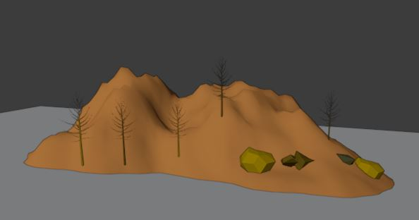

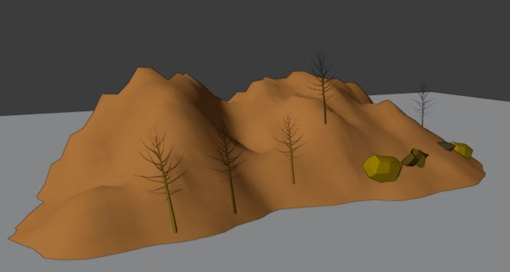

**Google Drive Link:** [**https://drive.google.com/drive/folders/1YmOPXtTCAxfUX7P_KA124rzgYNk6Os-m?usp=sharing**](https://drive.google.com/drive/folders/1YmOPXtTCAxfUX7P_KA124rzgYNk6Os-m?usp=sharing)